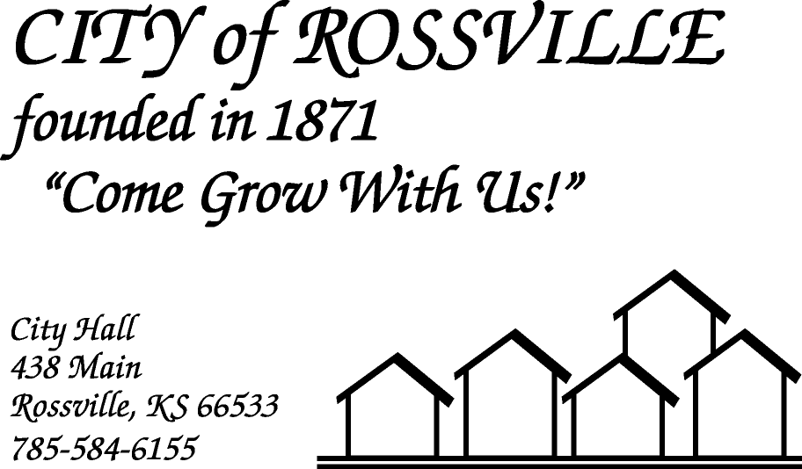

**AGENDA**

**MONDAY**

**NOVEMBER 16, 2020**

***AGENDA SUBJECT TO CHANGE***

7:00 pm MINUTES

BILLS

ADOPT AGENDA

7:05 pm COUNCIL REPORT

7:10 pm UTILITY DEPT REPORT/BUSINESS

7:25 pm POLICE DEPT REPORT/BUSINESS

7:35 pm OLD BUSINESS

Holiday Celebration Dinner

7:45 pm NEW BUSINESS

FEMA Silverjackets Report

CMB License-Casey’s General Store

7:55 pm ADJOURN

**NOTE: The meeting will be online using ZOOM meeting service**

Meeting ID: 844 1299 3724  
Passcode: 175778

**Please call City Hall at 785 584-6155 if you need assistance.**